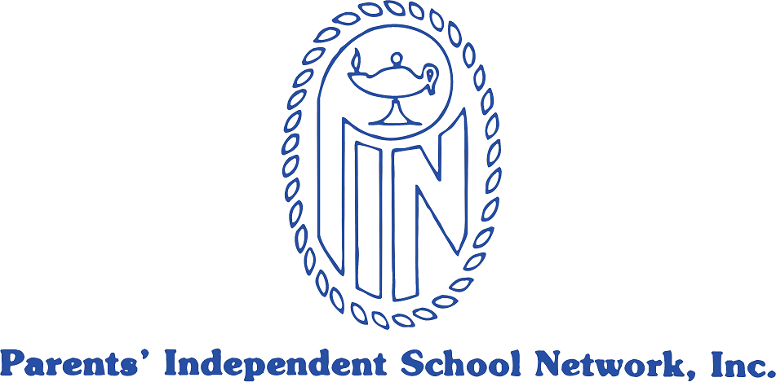

Calendar of Upper School PIN Meetings

2017-2018

Coffee at 9:00 am

Meeting begins at 9:30 am

Wednesday, September 27
Chestnut Hill School, Chestnut Hill, MA
PIN Rep Kick-Off meeting
“Diversity and Pluralism” discussion led by Dr. Carlos Hoyt

Tuesday, October 17
7:00 - 9:00 pm (note that this is an evening meeting)
Beaver Country Day School, Chestnut Hill, MA
5th Annual College Panel
College of Charleston, Boston University, Bucknell University, University of Vermont

Friday, November 17
Dana Hall School, Wellesley, MA
Joani Geltman, MSW
Adolescent Psychology: The Parent Version

Friday, January 26
Concord Academy, Concord, MA
Annual Meeting/Head of School Panel
Innovative Curriculum: Preparing Kids for the Future

Friday, February 23
The Rivers School, Weston, MA
Sally Taylor
The Importance of the Arts in Education

Wednesday, April 25
Charles River School, Dover, MA
Annual Community Service Presentations and Awards

