Milton Academy Milton-Nobles Challenge October 22nd to November 10th, 2018

Each year Milton and Nobles faces off to see which school can bring in the most young alumni donors by midnight on Milton-Nobles Day. Here are this year’s details:
- When: Monday, October 22nd through Milton/Nobles Day on November 10th at midnight.
- Who: Young Alumni Classes from 2004-2018.
- How: Each young alumni gift counts as one point to the score. This is a participation challenge so a gift of any size will earn Milton a point.
- Your role:
GIVE: All Milton Fund gifts received during the challenge dates will count as a point. Visit www.thechallengeison.com, call us at (866) MILTON-1, or find us on social media!
SHARE: Spread the word about The Milton-Nobles Challenge! Post on Facebook, Twitter, Instagram, or email to share why giving back to Milton is important to you. To help, we’ve created some sample messages to share.
ASK: Ask your network to join you in beating Nobles by making a donation to the Milton Fund!

Sample posts for social media

Share why you gave to the Milton/Nobles Challenge and what you love about Milton! Below are a few sample posts and tweets to get you started. Remember to tag your friends to encourage them to like and/or share your message.

Facebook or Twitter:
- The Milton-Nobles Challenge is on! I made my gift to Milton today – will you join me? #BeatNobles www.thechallengeison.com
- I support Milton because (fill in the blank) #BeatNobles #GoMilton www.thechallengeison.com
- I’m proud to be a Mustang! Are you? #BeatNobles #mustangpride www.thechallengeison.com

Instagram:
- Snap a selfie in your orange and blue gear!
- Share your favorite “throwback” photo from your time at Milton
- Celebrate your Milton friendships with a recent photo
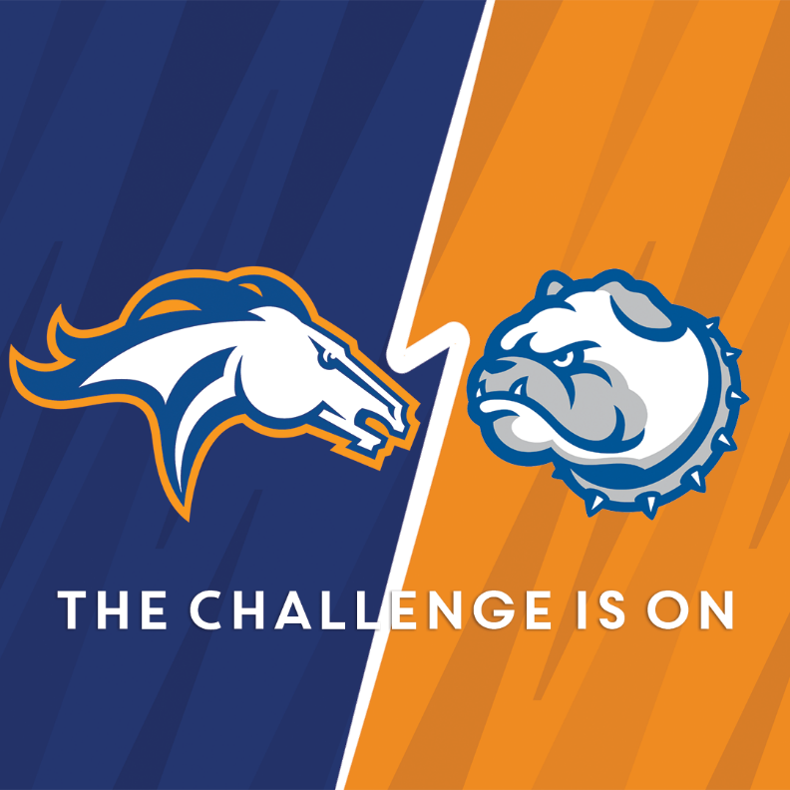
- Share one of our ready-made images:

Short on time? Share or retweet a post from Milton Academy’s Facebook, Twitter or Instagram account.

You can find progress updates on the Milton/Nobles Challenge and more information by visiting www.thechallengeison.com, or by following us on Facebook, Twitter, and Instagram.
Thank you for your loyalty to Milton Academy and for sharing in the excitement the Milton-Nobles Challenge!

For any questions or comments, please reach out to Jacob Clifton Albritton at jacob_clifton_albritton@milton.edu or 617-898-2386.

