Milton Academy
Parent/Guardian Response Form

Class of 2020
_______________________________________________________________________________________________

Part I - Your Child

Name of Student:

Name of Parent(s)/Guardian(s):

Parent(s)/Guardian(s) completing form:

Date:

We are seeking your thoughts and feelings about your child. Please help us by responding to the questions below. If you do not find these particular questions helpful, then write us a letter. Be funny; be serious; be honest; be proud. Your willingness to complete this form or write us a separate letter is very helpful in counseling your child and in writing the school letter. We will assume you have shared your responses with your child unless you tell us otherwise. Please return your response by mail or email to Sandi Dunnington (sandi_dunnington@milton.edu) or directly to your child’s college counselor by May 1, if possible.

(Note: If you fill out this form on your computer, the boxes below will expand as you type.)

- Describe one or two major events that you see as turning points in your child’s development and explain why you view them as such.

- Your child’s high school career has been pleasurable/painful because… (Don’t hesitate to write about both aspects.)

- Your child’s greatest strength/greatest weakness is…

- You are proud of our child because… (Specific anecdotes are particularly welcome.)

5) Something the College Counseling Office needs to know about your child is…

6) If there are any particular colleges you would like your child to consider, please feel free to share them below.

7) Will financial aid be a factor in your child’s decision?

- Are there any other family-related factors that will influence your child’s decision?

- Does your child have a learning disability that has warranted special accommodations?
Yes No

If so, do we have your permission to discuss it in the school letter as a way of providing context for your child’s academic performance? (This is something you may want to discuss with us in person.)
Yes No

10) Is there anything else we need to know to help us in writing the school letter about your child? (e.g. educational background, special family situation, special medical history, personal achievements, etc.)

Part II - And Now A Little Bit About You…

1) What are your hopes for your child in the coming year?

2) What are your primary concerns as your child enters the college process?

3) In what ways do you hope the College Counseling Office will help you address those concerns?

4) What are the first thoughts that come to mind when you think back to your own high school and/or college years? Will these thoughts have an influence on your hopes for your child?

Thank you!

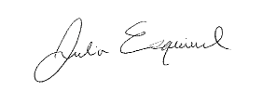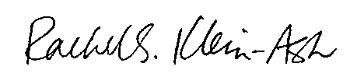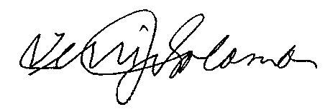

Julia Esquivel Amy Kirkcaldy Rachel S. Klein-Ash Rod Skinner Terri James Solomon

