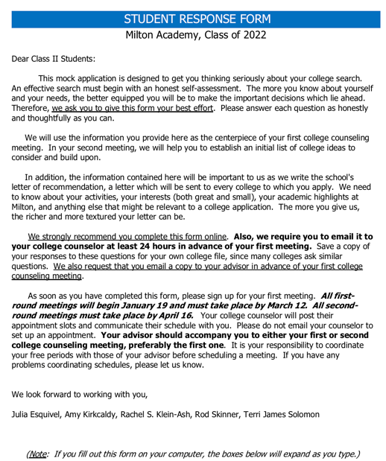

STUDENT:

First Name: | Middle: | Last:

Prefer to be called:

Pronouns used at school: | Pronouns used at home:

Permanent Address:

Home Phone: ( ) | Cell Phone: ( )

Date of Birth: | Alternate Email Address:

Came to Milton in Class: | Advisor:

Day Student: | Boarding Student: | Dorm:

Citizenship: | If not a U.S. citizen, what visa do you hold?

Primary language spoken at home:

Will you (and/or your siblings) be the first in your immediate family to go to college?

Will you be applying for financial aid? Have you talked with your parents/guardians about this?

School(s) attended prior to Milton:
Name | Location | Grades of Attendance

PARENT/GUARDIAN 1:

First Name: | Middle: | Last:

Occupation:

Name of business or organization:

Email: | Cell Phone:

Colleges(s) attended:

Name | Year Graduated | Degree

PARENT/GUARDIAN 2:

First Name: | Middle: | Last:

Occupation:

Name of business or organization:

Email: | Cell Phone:

Colleges(s) attended:

Name | Year Graduated | Degree

MARITAL STATUS/FAMILY STRUCTURE:

Please explain any family circumstances of which we should be aware. (For example, if your parents/guardians are separated or divorced, with whom should we be in contact?)

SIBLINGS:

First Name | Age | School/College Attended | (Occupation)

EXTRACURRICULAR ACTIVITIES:

Tell us your five most significant activities, the ones that really mean the most to you. In your answers, be
sure to note why the activity is meaningful, how much time you devote to it, and what you have learned about
yourself from it.

1.
2.
3.
4.
5.

QUESTIONS:

1. Describe an academic experience that has been a highlight in your Milton years (a teacher, a class, a paper, a
project, a book). Focus on how it challenged or inspired you and on how you grew as a thinker and a learner.

2. Describe an important ritual or routine in your life. Or describe ways in which your family or your home com-
munity has shaped you.

3. How do you think you have changed/grown in your time at Milton?

4. What do you really care about? What stance would you take even if it meant being unpopular?

5. How have you spent the last two summers? What are your plans for this summer? Include any jobs you
have held.

6. Are there any circumstances that have affected your life over the past year (COVID-19, other)?

7. Excluding the items listed elsewhere in this form, please tell us three fun, quirky, unique, interesting things
about you, things we wouldn’t know otherwise, that paint a more detailed picture of who you are.

1.
2.
3.

8. At this time, what personal, educational, or career goals do you have in mind? What areas of study might
you like to pursue in college? If you’re not thinking of going to college, do you have any clear idea about what
you hope to do in the future? Where do you see yourself in ten years? (Have fun with this one!)

9. Are there any outside circumstances that have interfered with your academic performance? Is there anything
on your transcript that needs explanation or clarification? (Please know we are already addressing the change in
grading policy for your Class IV year and the realities of COVID hybrid/remote learning.)

10. Have you ever been suspended, dismissed, or placed on probation from school or school-related programs for
academic or disciplinary reasons? If so, please explain. Have you ever had to leave school for an extended period of time? If so, please explain.

11. Do you have a learning difference that has warranted special accommodations?
Yes No

If so, do we have your permission to discuss it in the school letter as a way of providing context for your aca-
demic performance? (We should definitely talk about this during your college meeting.)

Yes No

12. Who at Milton Academy knows you best? (Please include names of students and adults, such as staff,
teachers, coaches, administrators, etc.)

ADJECTIVES:

List six words that you, your family, or your friends would use to describe you. How do you hope others
view you? What would others say about you?

1. | 4.
2. | 5.
3. | 6.

HODGE-PODGE:

Obviously there are no “right” or “wrong” answers to the following items. Your replies will help us to know
you a little better.

Favorite book: | Favorite keepsake:
Favorite song: | Favorite personal accomplishment:
Favorite activity/hobby: | Favorite academic subject:
Favorite movie: | Favorite website, blog, or podcast:
Favorite food: | Favorite word:
Favorite quotation: | Favorite memory:

For those of you at Milton in ninth grade, Class IV Talk topic:

You’re almost done!

FREE WRITING (REQUIRED):

We want to get to know you beyond the responses mentioned thus far. Tell us something important or
whimsical about you that this questionnaire may have missed, or leave us with an anecdote that you feel re-
veals something about your personality. Please be open and candid, and feel free to be creative. It need not
be structured; stream of consciousness writing is fine; so, too, is a list of thoughts.
,

